TO | Andy Woolhouse
COPY | Niroy Sumeran (Bay of Plenty Regional Council)
FROM | Keith Hamill
DATE | 16 October 2017, updated on 25 September 2018
FILE
SUBJECT | Lake Ōkāreka overflow, Waitangi Stream: Ecology effects of increased flow. Resource consent application CH17-00717
Introduction
Lake Ōkāreka does not have a natural surface outlet, instead a gravity pipeline provides a controlled outlet to the Waitangi Stream. The existing resource consent allows a maximum outlet flow of 239 L/s. High rainfall during 2017 increased the level of Lake Ōkāreka beyond typical ranges and threatened property. The Bay of Plenty Reginal Council (BOPRC) responded by utilising the emergency works provision (S330) of the RMA to increase the outflow from the lake to 500 L/s (about 345 L/s from the existing pipe and 155 L/s from an additional pipe and pump).
BOPRC initially applied for an emergency consent to increase the discharge of water from Lake Ōkāreka to the Waitangi Stream from 240 L/s to 500 L/s. BOPRC is now applying for a new consent to address the long-term management of lake levels and discharge rates.
As part of the consent variation for emergency works I prepared a memo (16 October 2017) that provided an ecological assessment of increasing the flow from 240 L/s to 500 L/s and to address questions raised in a section 92 request. The effects assessment undertaken in in the memo is applicable to the long-term consent application and I have summarised it below. In addition, I have made additional comments on the long-term design solution as described in the document titled ‘Waitangi Stream Remediation and Erosion Protection, Issued for Tender’.

Existing environment
Waitangi Stream was originally a spring fed stream that flowed to Lake Tarawera. A gravity pipe was installed in 1965 to carry water from Lake Ōkāreka to the head of Waitangi Stream with the purpose of controlling the water level in Lake Ōkāreka. The base flow of the Waitangi springs in 1963 was about 400 L/s but estimates from the 1990’s indicated a reduced flow of about 100 L/s – probably due to the lower level of Lake Ōkāreka (EBOP 1999).
The lower section of Waitangi Stream, below the natural waterfall, is an important trout spawning area. The waterfall is a natural barrier that prevents trout from moving further upstream but could be negotiated by native fish. Upstream fish passage is not possible through the gravity pipeline to Lake Ōkāreka, and two culverts may also form a fish passage barrier during high flows (Figure 1).
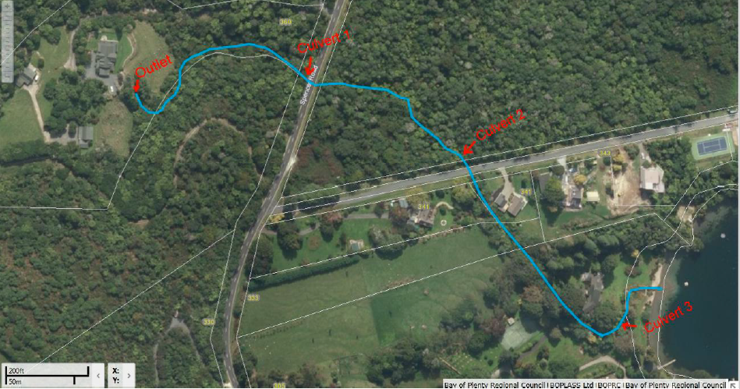
waterfall
Figure 1: Waitangi Stream from pipe outlet structure to Lake Tarawera.

Potential effects previously identified in 16 October 2017 memo
The memo from 16 October 2017 identified two main potential effects of increasing the water flow in Waitangi Stream from 240 L/s to 500 L/s, these are:
- Restricting fish passage to up the Waitangi Stream. The waterfall on Waitangi Stream forms a natural fish barrier to non-climbing fish species and it is likely that all of the culverts are partial fish barriers even under consented flows (i.e. 240 L/s). However, the recently high stream flow (500 L/s) will have increase water velocity through the culverts and further reduced potential for fish passage.
- Effects on stream benthic fauna by scouring of the stream bed. This was particularly apparent downstream of culvert 2 but was mitigated by emergency works undertaken by BOPRC including placing boulders at the culvert outlet to protect from scouring, installing felt cloth and plywood panelling along the stream bank to minimise erosion and installing plywood weirs to reduce water velocities.
Potential effects of the higher flow on water quality in Waitangi Stream or in Lake Tarawera were considered to be negligible. However, erosion of the Waitangi Stream from the high flows may cause a short-term reduction in water clarity. The higher flow rates were assessed as having negligible difference on the transfer of organisms between the lakes.
Recommendations made to mitigate the potential effects in the long term were:
- Installing baffles through culverts 1 and culvert 2;
- Removing the temporary wooden structure on the culvert 3 and constructing a rock v-vane weir about 3m upstream of the culvert.
- Providing permanent features downstream of culvert 2 to protect the stream from erosion and scour while also providing hydraulic heterogeneity and instream habitat for macroinvertebrates and fish. Features included rock v-vane type structures, bank protection and reinstating gravel/cobble substrate.
The 16 October 2017 memo concluded:
“Increasing the flow of the Waitangi Stream to 500 L/s has caused erosion of the stream bed between Culvert 2 and the waterfall. This has removed what is likely to have been high qualtiy habitat for aquatic macroinvertebrtes. The stream habitat above the waterfall has potential to support fish species with the ability to climb, but the increase in water velocity is likely to be restricting fish passage through the existing culverts. Some of the exiting culvert may have been fish barriers even before the increase in stream flow. Recommendations are made on how to mitigate these effects in the long term.”
This assessment of effects undertaken for the emergency works is also applicable to the long-term consent.
Long-term design solution
Downstream of waterfall
Designs for the long-term design solution downstream of the waterfall includes:
- Replacing existing weirs with rock j-hook weirs and v-vane weirs;
- Adding a v-vane weir upstream of culvert 3; and
- Cementing rocks into culvert 3 to provide better fish passage.
These actions are consistent with my previous recommendations and improve fish passage and provide better hydraulic and habitat diversity for aquatic life.
The design also provides for sections of timber retaining wall/sleeper and rock rip-rap/gabion baskets along the stream edge. Sections of bank protection are often necessary and appropriate (e.g. when used in association with a v-vane) but often reduces habitat and cover on the stream bank. Timber walls can be a particular issue as they provide almost no riparian cover unless they are modified or planted to allow vegetation to overhang close to the water. In one survey I found eight times less fish abundance in a section of stream with timber retaining walls compared to adjacent sections with grassed stop banks.
In order to maintain or enhance the stream edge habitat values I recommend that the proposed rip-rap and retaining wall is minimised, and where it is required:
- Place rip-rap/gabion baskets in association with large boulders providing gaps between the rocks as fish cover.
- Re-establish riparian vegetation on stream edge so that it can over-hang the water. This might include planting on top of gabion baskets.
- Keep wooden retaining walls as low as possible and plant riparian vegetation on top so that it can over-hang the water.
- Integrate habitat features into retaining walls to provide cover, e.g. 250mm horizontal boards just above water level, or planter boxes attached to timber retaining wall.
Downstream of culvert 2
Designs for the long-term design solution downstream of the waterfall includes:
- Rock gabion retaining structures on stream edge;
- Rock riprap (300mm to 500mm diameter) downstream of culvert 2 and on bends;
- Regrading of some slopes
- Installing a drop structures using riprap and gabion baskets.
This work will result in short term impacts on about 56m of stream. The stream section will be temporarily piped to enable the works. Fish abundance in this section of the stream is likely to be low due to the waterfall downstream acting as a fish barrier, nevertheless there is a risk that any fish present in the stream section could be stranded. This effect can be mitigated by implementing a fish rescue procedure at the time water is diverted into the temporary pipe. I recommend that fish rescue occur on the day the stream section is temporarily piped and consist of removing any fish from pools that remain after the section is dewatered.
The current design poses a risk of the stream flowing subsurface through the rock rip-rap (and gabion baskets at cross-section F) during periods of low flow. To minimise this risk the rip-rap on the stream base should be built-up in layers with voids partially filled with finer material, e.g. geotextile fabric, covered by a layer of gap 40mm, layer of 400mm riprap, layer of gap 40mm etc. In addition, geotextile material could be run vertically through the rip-rap base to help retain fine sediment and reduce water flow through the riprap. A similar approach may be required for some of the gabion baskets to avoid sub-surface flows.
The current design shows the final stream channel to be 1.5m to 3m wide and profiled to have a horizontal base. I recommend that the base channel is not left horizontal but instead profiled to have a V-shape or a small baseflow channel to contain water during low flows. This will also provide more hydraulic heterogeneity.

References
Environment Bay of Plenty 1999.Lake Ōkāreka level control. Operations Report 98/18
Hamill KD 2017. Lake Ōkāreka overflow, Waitangi Stream: Ecology effects of increased flow. Resource consent application CH17-00717. Memo to Andy Woolhouse, 16 October 2017, from River Lake Ltd.

