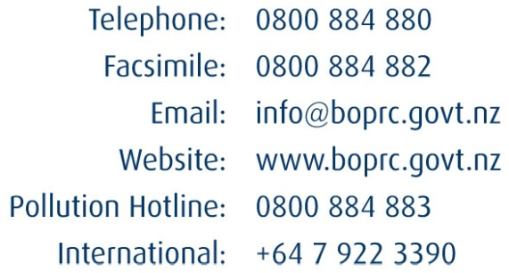
File ref:

 | SEEN |  | SEEN

Office Use Only

Resource Management Act 1991 (s.95E(3)(a)/95F(c))
8A Affected Person’s Written Approval

To: Bay of Plenty Regional Council
Full name of person giving written approval:
I am the owner/occupier (delete one) of the property at (address)
I have authority to sign on behalf of all the other owners/occupiers (delete one) of the above property.
Note: If you are signing on behalf of a trust or company, please provide additional written evidence that you have signing authority.
This is written approval for the following activity that is the subject of a resource consent application.
Applicant’s name
Application number (if known)
Description of proposal
Location
I have read the full application for resource consent, the Assessment of Environmental Effects (AEE), and any site plans as follows:

In signing this written approval, I understand that the Bay of Plenty Regional Council must decide that I am no longer an affected person, and the Bay of Plenty Regional Council must not have regard to any adverse effects on me.
I understand that I may withdraw my written approval by giving written notice to the Bay of Plenty Regional Council before the hearing, if there is one, or, if there is not, before the outcome of the application is determined.
Date
Signature* of person giving written approval (or person authorised to sign on behalf of person giving written approval).
A signature is not required if you give your written approval by electronic means.
Address for service (of person giving approval)

Telephone Email
Contact person (name, and designation if applicable)
*Notes: 1 There is no obligation for you to sign this form, and no reasons need be given. If you do not understand what this form is, or details about the application, DO NOT SIGN IT.
2 Conditional written approvals cannot be accepted.
3 If this form is not singed, the application may need to be notified with the opportunity for submissions

