A guide to your Regional Council 2014
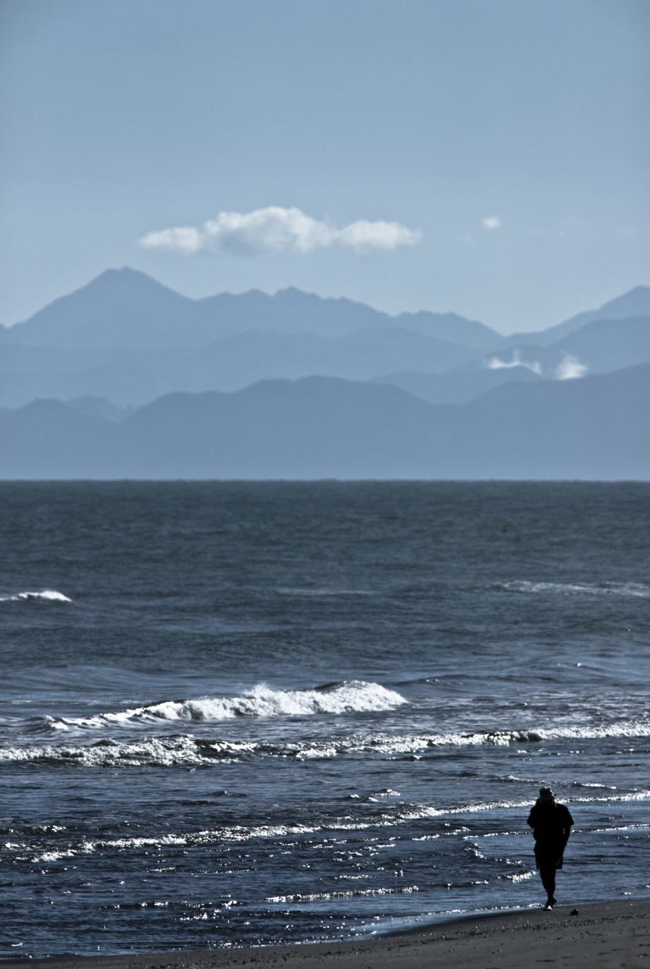

Bay of Plenty Regional Council

About us

Our region

- Twenty one thousand, eight hundred and thirty six (21,836) square kilometres of land and sea (12,253 land, 9,583 sea).
- Eighteen offshore islands including Matakana, Tūhua (Mayor), and Whakaari (White Island) (an active volcano).
- The coastline stretches from the southern end of Homunga Bay (north of Waihī Beach) to Lottin Point near Cape Runaway.
Prominent features include:
- Three mountains - Tarawera, Putauaki (Mt Edgecumbe) and Mauāo (Mt Maunganui).
- Two harbours - Tauranga and Ōhiwa.
- Five estuaries - Maketū, Little Waihī, Whakatāne, Waiotahi and Waioeka/Otara.
- Twelve Rotorua lakes - Ōkāreka, Ōkaro, Ōkataina, Rerewhakaaitu, Rotoehu, Rotoiti, Rotokakahi, Rotomā, Rotomahana, Rotorua, Tarawera, Tikitapu, plus many other regional lakes including Rotokawau and Matahina.

The furthest point from the coast is 139 km from the sea at the top of the Rangitāiki River catchment.
Eight major rivers - Wairoa, Kaituna, Tarawera, Rangitāiki, Whakatāne, Waioeka, Mōtū and Raukōkore.
Population
About 267,700 people live in the Bay of Plenty.
In each district:
- Western Bay of Plenty 43,692
- Tauranga City 114,789
- Rotorua 68,600
- Whakatāne 32,691
- Kawerau 6,363
- Ōpōtiki 8,436

(These are population counts from the 2013 census. Only parts of the Rotorua and Taupō districts are within our boundary.)
Who are we?
- We’re the Regional Council for the entire Bay of Plenty.
- We look after the region’s land, air, freshwater, coast, passenger transport and regional development, focusing on sustainable development.
- We have 14 councillors, of whom 11 are elected from general rolls and three from Māori constituencies.
- We have four offices – Whakatāne, Mount Maunganui, Tauranga and Rotorua.
- We have two depots – Edgecumbe and Ōpōtiki.
- We employ about 275 staff.

We are separate from the seven territorial authorities in the region - Whakatāne, Ōpōtiki, Western Bay of Plenty, Kawerau, Rotorua and Taupō District Councils and Tauranga City Council.
District and city councils
- Provide local infrastructure, including water, sewerage, stormwater, roads and footpaths.
- Provide community infrastructure, including parks, museums, playgrounds and recreation centres.
- Regulate building controls, liquor licensing, public health inspections, animal control and other local issues.
- Control the effects of land use through planning and resource consents (including building sizes, shadowing and signage).
What we do and how we do it
Our work guides and supports sustainable development of the Bay of Plenty. We want to make sure our region grows and develops in a way that keeps its values safe for future generations.
A major focus of our work involves looking after the environment. We manage the effects of people's use of freshwater, land, air and coastal water. This includes issuing resource consents for people to use environmental resources and monitoring that use, dealing with pollution incidents and prosecuting offenders, and providing information to help our residents care for and use resources sustainably. However, we also have a broader responsibility for overseeing economic, social and cultural interests of the regional community.
Our work includes:
- Managing risks posed by our major rivers, including the region's major flood control schemes.
- Planning and prioritising the region's land transport needs, including major roading improvements.
- Organising passenger transport services, including Tauranga's Bay Hopper and Rotorua's Cityride.
- Navigation and safety on our harbours and lakes.
- Supporting sustainable economic development.
- Strategic thinking for our region's future.
What guides us?
Three key pieces of Government legislation guide our work:
- Local Government Act 2002.
- Resource Management Act 1991.
- Local Government Official Information and Meetings Act 2002.

The Local Government Act 2002 sets out the purpose of Local Government in New Zealand. It gives us a framework for which activities we do and how we do them, making us accountable to our communities.
Our overall role is to ensure democratic local decision-making and action by, and on behalf of, communities. We must meet the current and future needs of communities for good-quality local infrastructure, local public services and performance of regulatory functions in a way that is most cost-effective for households and businesses.
Local Government in New Zealand has been in a state of change over the past four years. The Local Government Act Amendment Bill (No 3) was released for consultation in late 2013 and is expected to be passed by Parliament as an Amendment Act before the start of the 2014/15 year. This Act is likely to change some of the ways we do our work.
Some of our documents fall directly out of the Local Government Act 2002, including:
- Long Term Plans.
- Annual Plans.
- Annual Reports.
- Code of Conduct for Elected Members.

The Resource Management Act 1991 (the RMA) is legislation that sets out how we should manage our environment. It’s based on the idea of sustainable management of our resources, and it encourages us (as communities and as individuals) to plan for our environment’s future. This diagram sets out the process under the Resource Management Act:
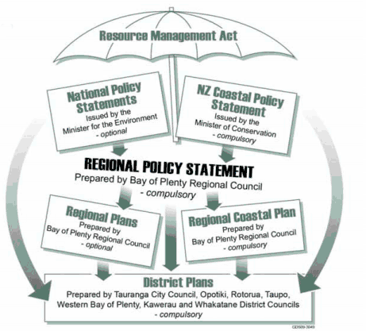

We have created regional plans and a Regional Policy Statement to help us manage our environment.
Our key regional plans include:
- Regional Water and Land Plan.
- Regional Coastal Environment Plan.
- Regional On-Site Effluent Treatment Plan 2006.
- Rotorua Geothermal Regional Plan.
- River Gravel Management Plan.
- Regional Air Plan.

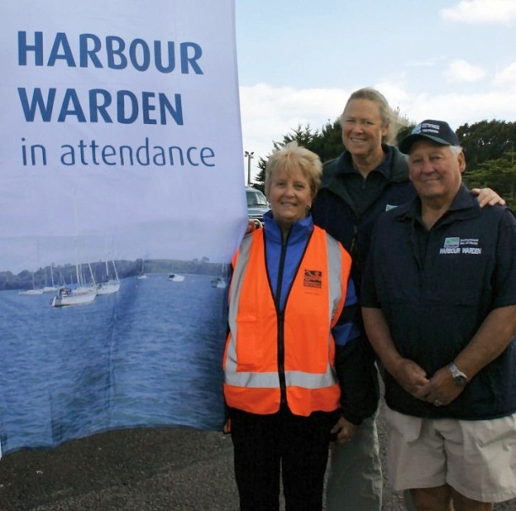
We’ve also created other plans, strategies and bylaws to help us manage our other responsibilities.
These include:
- Regional Land Transport Strategy.
- Regional Passenger Transport Plan.
- Regional Pest Management Strategy.
- River and Drainage Scheme Asset Management Plans.
- Navigation Safety Bylaw.
- Tier II Oil Spill Response Plan.
- Floodway and Drainage Bylaw.
- Contributing to the Regional Civil Defence Emergency Management Group Plan, and resourcing response to emergencies.

These documents are statutory, meaning either they are required by legislation or they have a regulatory impact. Non-statutory documents may not be ‘law’, but we use them to guide us in the decisions we make and in our actions. They include other strategies and our policies, environmental publications and guidelines.

There is also local legislation that applies only to Bay of Plenty Regional Council.
These are:
- Bay of Plenty Regional Council (Māori Constituency Empowering) Act 2001.
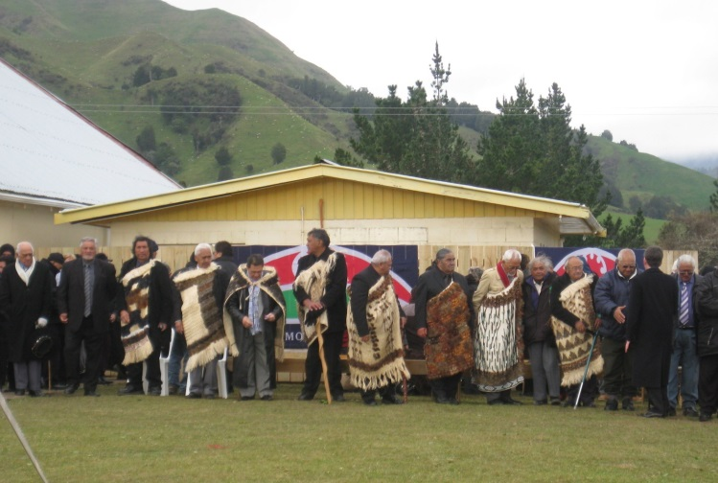
- Local Government (Infringement Fees for Offences: Bay of Plenty Regional Navigation Safety Bylaw 2010).
- Rangitāiki Land Drainage Act 1956.
- Ngāti Tuwharetoa (Bay of Plenty) Claims Settlement Act 2005.
- Affiliate Te Arawa Iwi and Hapū Claims Settlement Act 2008.
- Ngāti Manawa Claims Settlement Act 2012.
- Ngāti Whare Claims Settlement Act 2012.
Strategies and policies
We develop joint strategies with our partners to work on major issues which need several parties delivering coordinated way.
Major joint strategies include:
- Strategy for the Lakes of the Rotorua district.
- Tauranga Harbour Strategy and Tauranga Harbour Recreation Strategy.
- Ōhiwa Harbour Strategy.
- Kaituna River Re-diversion and Wetland Creation Project.
- Bay of Plenty Regional Waste Strategy.
- Bay of Plenty Civil Defence Emergency Management Group Plan.
- Water Programme of Action.
- Bay of Connections, the region’s economic strategy.

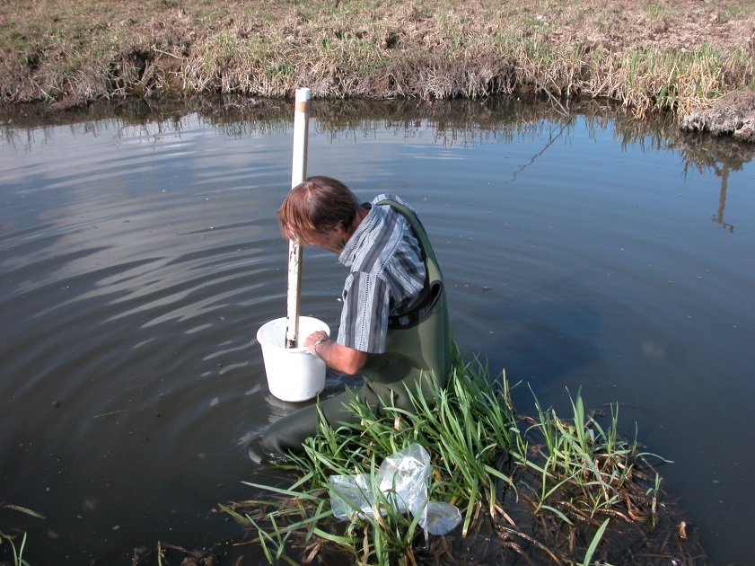
We also work closely with partners and agencies both inside our region and outside it.
We are a member of UNISA, the Upper North Island Strategic Alliance, which includes territorial authorities from Tauranga city, Auckland, Whangarei district and Hamilton city as well as the regional councils from Bay of Plenty, Waikato and Northland.
We work with Rotorua District Council and Te Arawa Lakes Trust to preserve and protect the Rotorua lakes, we work with Tauranga City Council and Western Bay of Plenty District Council on SmartGrowth, a growth management strategy for the western bay, and we work with several agencies, Ōpōtiki and Whakatāne District Councils and iwi to oversee implementation of the Ōhiwa Harbour Strategy.
We can help you with…
- Advice for managing soils, water and pests.
- Riparian and stream management.
- Environmental education.
- Resource consents.
- Navigational safety.
- Freshwater allocation and quality.
- Air quality.
- Passenger transport.
- Coast and Estuary Care support.
- Environmental monitoring data.

What kind of work do we do?
Staff do a wide variety of jobs at Bay of Plenty Regional Council. They include:
- Planners (resource, environmental, transport, strategic policy).
- Land management officers.
- Biosecurity officers.
- Pollution prevention officers.
- Environmental scientists.
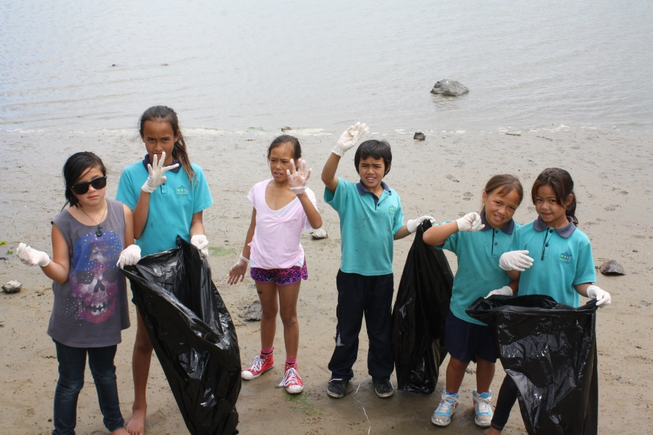
- Graphic designers.
- Communications advisors.
- Community engagement officers.
- Accounting and finance.
- IT technicians and programmers.
- Coast Care and Estuary Care officers.
- Engineers.
- Customer services officers.
- Pest plant and pest animal officers.
- Human resources.
- Nutrient assessment officers.
- Consents officers.
- Harbourmasters and maritime officers.

Bay of Plenty Regional Council’s Chief Executive Mary-Anne Macleod is the only staff member employed by the Council. The Chief Executive is responsible for employing all other staff.
Our environmental publications
We produce a number of environmental publications, reports and guides. These include compliance monitoring reports, environmental impact monitoring reports and Natural Environmental Regional Monitoring Network (NERMN) Reports.
Guides to environmental practices you can get from us:
- Coast Care.
- Dairy shed effluent.
- Farmers guide to regional plans.
- Earthworks.
- Erosion and sediment control for land disturbing activities.
- Erosion protection for Tauranga Harbour.
- Forestry operations.
- Hydrological and hydraulic.
- Iwi consultation.
- Land management/biodiversity protection.
- On-site effluent treatment.
- Plant and animal pest control.
- Quarry operations.
- Resource consent consultation guidelines.
- River gravel management.
- Small flood detention dams.

For more information about these plans,
visit our website www.boprc.govt.nz
How does our Council work?
How are Councillors elected?
Our 14 Councillors are elected every three years in a postal vote, by those registered to vote in the Bay of Plenty. We use the First Past the Post electoral system – voters choose their most preferred candidate or candidates. Those with the most votes (depending on the number of seats to be filled) win the election.
Under the Local Electoral Act 2001 the Council can resolve to change the electoral system used. Once changed, an electoral system must be used for at least the next two elections. For example we cannot change our electoral system for one election and then change back for the next election.
Representation is assessed at least once every six years, to ensure it is a fair representation of population change. Council’s last review of electoral systems was in late 2012, when a fifth councillor was added to the Tauranga City constituency.
Where do they come from?
Bay of Plenty Regional Council’s 14 Councillors are elected from four general constituencies (Tauranga, Western Bay of Plenty, Rotorua and Eastern Bay of Plenty) and three Māori constituencies (Kōhi, Mauāo and Ōkurei).

Māori constituencies
In the Bay of Plenty, Māori who are registered on the Māori Roll can vote for their own representatives. Other councils are now following our lead and creating their own Māori seats.
Constituency | Councillor
Eastern Bay of Plenty  General | 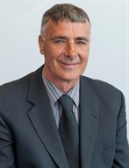 | Doug Leeder  Chairman  160 Gabriels Gully Road  RD 2  Ōpōtiki 3198  Home ph: 07 315 4839  Mobile ph: 027 292 8048  douglas.leeder@boprc.govt.nz
Western Bay of Plenty  General |  | Jane Nees  Deputy Chair  440B Joyce Road  Pyes Pa  Tauranga 3173  Home ph: 07 579 5150  Work ph: 07 579 5150  Mobile ph: 027 485 9919  jane.nees@boprc.govt.nz
Tauranga General |  | John Cronin  41 Edgecumbe Road  Tauranga 3110  Home ph: 07 578 0001  Mobile ph: 021 578 001  Fax: 07 578 0002  john.cronin@boprc.govt.nz
Tauranga General | 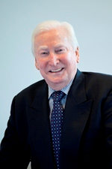 | Philip Sherry  1 Monaco Key  Pāpāmoa Beach  Home ph: 07 575 7868  philip.sherry@boprc.govt.nz
Tauranga General | 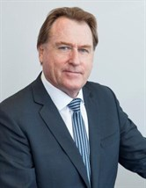 | Douglas Owens  PO Box 5485  Mount Maunganui 3150  Home ph: 07 572 0807  Mobile ph: 027 447 7699  Fax: 07 572 0935  douglas.owens@boprc.govt.nz
Tauranga General |  | Paula Thompson  69 The Drive  Brookfield  Tauranga 3110  Home ph: 07 576 1373  Work ph: 07 576 1373  Mobile ph: 027 222 2419  paula.thompson@boprc.govt.nz
Tauranga General | 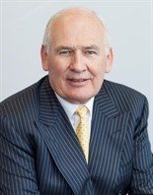 | David Love  75 Bathurst Crescent  Pyes Pa  Tauranga 3112  Home ph: 07 543 2118  Work ph: 07 572 4000  Mobile ph: 027 427 3601  david.love@boprc.govt.nz
Rotorua General | 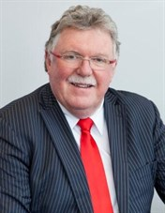 | Lyall Thurston  19 Moncur Drive  Rotorua 3015  Home ph: 07 348 6768  Mobile ph: 0274 966 499  lyall.thurston@boprc.govt.nz
Rotorua General | 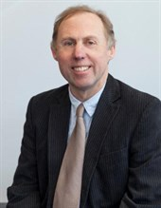 | Neil Oppatt  11 Steep Street  RD 5  Lake Ōkāreka  Rotorua 3076  Mobile ph: 021 708 052  Home ph: 07 362 8424  neil.oppatt@boprc.govt.nz
Eastern Bay  of Plenty General | 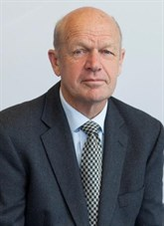 | Colin Holmes  4465 Galatea Road  RD 1  Murupara 3079  Home ph: 07 366 4850  Work ph: 07 366 4850  Mobile ph: 021 272 0400  colin.holmes@boprc.govt.nz
Western Bay  of Plenty General | 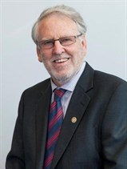 | Norm Bruning  1245 State Highway 2  RD 2  Ōmokoroa  Tauranga 3172  Home ph: 07 548 0617  Work ph: 07 548 0617  Mobile ph: 021 125 6958  norm.bruning@boprc.govt.nz
Mauao Maori | 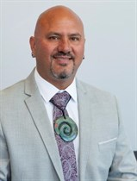 | Awanui Black  1 Kaiwha Road  RD 5  Welcome Bay 3175  Home ph: 07 544 7835  Mobile ph: 021 225 5503  awanui.black@boprc.govt.nz
Okurei Maori | 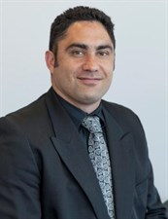 | Arapeta Tahana  112 Homedale Street  Pukehangi  Rotorua 3015  Home ph: 07 362 7603  Work ph: 07 349 0350  Mobile ph: 021 348 748  arapeta.tahana@boprc.govt.nz
Kohi Maori | 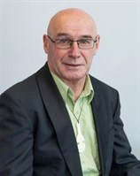 | Tiipene Perenara Marr  36 Domett Street  Kawerau 3127  Home ph: 07 323 8909  Mobile ph: 027 370 1126  tiipene.marr@boprc.govt.nz
Constituency maps (– Governance should have these)
What do Councillors do?
Bay of Plenty Regional Council’s elected members:
- Set the policy direction of Council.
- Employ the Chief Executive.
- Represent the interests of the Bay of Plenty’s current and future residents.
- Monitor Bay of Plenty Regional Council’s performance as a whole.

Their purpose is:
- To enable democratic local decision-making and action by, and on behalf of, Bay of Plenty communities.
- To meet the current and future needs of communities for good-quality local infrastructure, local public services and regulatory functions in the most cost-effective way for households and businesses.
- To set the overarching strategic direction for Bay of Plenty Regional Council as an organisation.
- To provide strategic oversight of the Council’s financial affairs.
How does the Council work?
The Council has a Chairman, Doug Leeder, and Deputy Chair, Jane Nees. It meets as a full Council every six weeks, and has several committees and joint committees to help it make decisions.
The Chairman is responsible for maintaining order at meetings and has the power to remove any member of the public for disorderly conduct, or remove a Councillor who does not comply with standing orders.
For an ordinary meeting of Council, at least 14 days’ notice of the time and place of the meeting must be given. Extraordinary meetings may be called at three working days’ notice. Legal requirements for Council meetings are set down in the Local Government Act 2002 and the Local Government Official Information and Meetings Act 1987. You can obtain a copy of the code of conduct and standing orders from any of Bay of Plenty Regional Council’s office.

Core Committees
Regional Direction and Delivery Committee
- Sets the strategic direction for the region by formulating policy that clearly identifies Council’s role and direction on issues. Develops and approves Council strategy and policy.
- Sets the operational direction for approved Regional Council policy and strategy, and monitors how it is implemented. Develops specific operational decisions which translate policy and strategy into action.
- Membership: Chairman and all councillors.
Audit and Risk Committee
- Develops and reviews the Council’s funding and financial policies and frameworks, performance monitoring framework and the Council’s audit and risk policies and frameworks.
- Membership: Five councillors and the Chairman as Ex-Officio.
Māori Committee
- Sets operational direction for the Council’s legislative obligations to Māori and monitors how these are implemented. Makes decisions which translate legislative obligations to Māori into action. Tangata whenua and any other member of the public are encouraged to participate at meetings held on marae across the region. Meeting standing orders are relaxed to allow for presentations.
- Membership: Three Māori constituency councillors and three general constituency councillors and the Chairman as Ex-Officio.

Statutory Committees
Regional Transport
- Prepares a Regional Land Transport Strategy and programme for the region, any variations and any reports.
- Approves submissions to Central Government, local authorities and other agencies on Regional Transport Committee-related matters.
- Membership: Two representing the Regional Council, one each from each territorial authority in the region and one representing the New Zealand Transport Agency.
Rotorua Te Arawa Lakes Strategy Group
- A joint committee with Rotorua District Council and Te Arawa Lakes Trust which coordinates policy and actions to improve Rotorua’s lakes. The partner organisations work together to protect and restore water quality in 12 Rotorua lakes for the enjoyment and use of present and future generations, while recognising and providing for the traditional relationship of Te Arawa with their ancestral lakes. The Group meets four to five times a year to coordinate policy and actions to improve the Rotorua lakes. It is established in law as part of the Te Arawa Lakes Settlement.
- Membership: Two each from Te Arawa Lakes Trust, Rotorua District Council and
Bay of Plenty Regional Council.
Civil Defence and Emergency Management Group Joint Committee
- Civil Defence Emergency Management Group (CDEMG) is a Statutory Committee responsible for co-ordinating planning, programmes and activities related to civil defence emergency management, including reduction, readiness, response and recovery.
- Membership: Representatives from Bay of Plenty Regional Council, Kawerau, Ōpōtiki, Rotorua, Western Bay of Plenty and Whakatāne District Councils and Tauranga City Council.

Rangitāiki River Forum
- Set up in 2012, the purpose of this Statutory Committee is to protect and enhance the environmental, cultural and spiritual health and well-being of the Rangitāiki River and its resources for the benefit of present and future generations. The Forum prepares and approves the Rangitāiki River Document. Bay of Plenty Regional Council must recognise and provide for the River Document when preparing or changing the Regional Policy Statement.
- Membership: One member each from Te Rūnanga o Ngāti Whare, Te Rūnanga o Ngāti Manawa, Ngāti Tūwharetoa (Bay of Plenty) Settlement Trust, Te Rūnanga o Ngāti Awa, Whakatāne District Council and three members appointed by Bay of Plenty Regional Council.

Joint Committees
SmartGrowth Implementation Committee
- The SmartGrowth Implementation Committee (SGIC) is the governance group responsible for prioritising, reviewing and monitoring implementation of the SmartGrowth Strategy 2051.
- Membership: Tauranga City Council Mayor and two councillors, Western Bay of Plenty District Council Mayor and two councillors, Bay of Plenty Regional Council Chairman and two councillors, tangata whenua three representatives, SmartGrowth Independent Chairman and an Implementation Advisor.
Eastern Bay of Plenty Joint Committee
- A collaboration between Bay of Plenty Regional Council, and Kawerau, Ōpōtiki and Whakatāne District Councils which responds to and manages a range of eastern
Bay of Plenty issues. The Committee forms, explores and makes recommendations for strategic collaborative initiatives between the partner councils.
- Membership: Two elected members each representing Regional Council, Kawerau, Ōpōtiki and Whakatāne District Councils.
Ōhiwa Harbour Implementation Forum
- Oversees and monitors implementation of the Ōhiwa Harbour Strategy.
- Membership: Elected members of Ōpōtiki and Whakatāne District Councils, Bay of Plenty Regional Council with four appointees from tangata whenua representing Whakatōhea, Upokorehe, Ngāti Awa and Ngāi Tuhoe.

Subcommittees
Public Transport Subcommittee
- Determines operational policy and operational matters for public transport. Develops and approves operational decisions which translate strategy and policy into action.
- Membership: Six Councillors including the Chairman as Ex-Officio and one representative each from Tauranga City Council and Rotorua District Council.
Regional Policy Statement Appeals Subcommittee
- This Subcommittee was established by the Regional Council in 2012 to guide resolution of Environment Court appeals on the Proposed Bay of Plenty Regional Policy Statement.
- Membership: Four Councillors and two Independent Commissioners.
Executive Employment and Remuneration Subcommittee
- Acts for and advises the Council on the employment of the Council's Chief Executive Officer.
- Membership: Chairman, Deputy Chair and two Councillors.
What you need to know about our meetings
Can I attend meetings?
Yes – you’re welcome to attend all open Council and committee meetings. All matters are discussed in public unless there is a good reason for excluding the public on a certain issue, such as commercial sensitivity.
Meeting agendas and records are available for viewing at Council’s offices and on our website www.boprc.govt.nz
Can I speak at meetings?
Time is set aside near the beginning of each meeting for a public forum. If you wish to speak at a meeting, you need to arrange this with Council staff before the meeting. Up to three people can speak per meeting. However, as Māori Committee meetings are held on marae, our standing orders are relaxed so that members of the public can have input.
Agendas and minutes
The Council agenda is a public document that sets out what will be discussed at a meeting. It includes information about the topics, although parts of it may be withheld if the information is privileged or commercially sensitive.
Minutes of meetings are kept and are publicly available, subject to the Local Government Official Information and Meetings Act 1987. Copies of Regional Council agendas and minutes are on our website.
All committees can make decisions without having to take them to the full Council. However, some decisions need to be made at full Council meetings:
- Making rates and bylaws.
- Borrowing money or purchasing or disposing of assets, where not provided for in the long-term council community plan (Ten Year Plan).
- Adopting a Ten Year Plan, Annual Plan or Annual Report.
- Adopting policies associated with the Ten Year Plan or developed for the purposes of the Local Governance Statement.

The full Council can also consider issues that don’t fall solely within the delegation of any one Council committee.
Future co-governance forums
Future co-governance forums are likely to be established throughout the region resulting from the Treaty of Waitangi settlements between Iwi and the Crown. Forums are currently being established for the Kaituna River and Tauranga Moana (Harbour). Additional co-governance forums may appear in the future as more iwi complete their Treaty settlements.
Workshops
The Council holds workshops to discuss some specific issues in depth so they can have a full and frank discussion. The Council is unable to make decisions at a workshop, and any matters arising must be considered at a later Council meeting for a decision to be made. These workshops are not open to the public.
Consultation – your chance to have a say
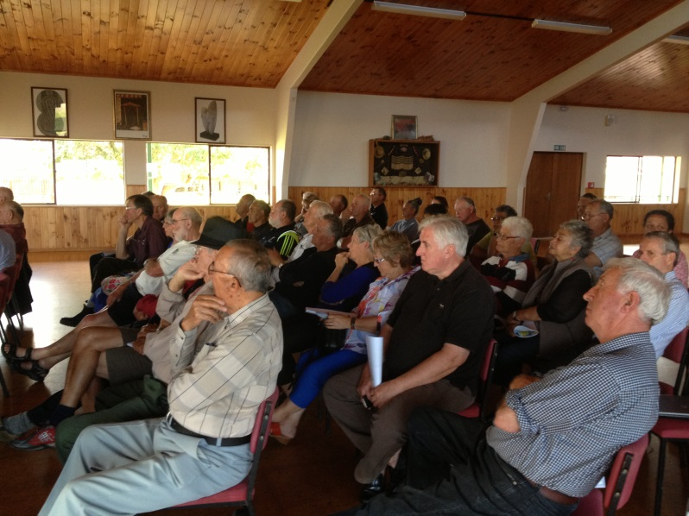
To make the best decisions about your environment and region, we need to know what you think about what we’re doing or planning to do.
We consult with the community to get feedback from interested or affected people on certain decisions we make, or issues we’re considering.
Who we consult with is guided by the law and varies depending on the type of issue. The Council must act in the best interests of the region as a whole.

How we consult with you
There are many different ways we use to find out what the community thinks about a particular issue, such as meetings, surveys, doing public displays, putting information in newspapers and on our website and formal submissions.
Our commitment is:
- To provide you with many ways to feedback to us, such as telephone, e-mail, freepost forms, formal and informal submissions and hearings and face-to-face conversations.
- To use publications that reach all households, such as community newspapers, when issues affect a whole community.
- To use our website and social media such as Facebook and Twitter to highlight matters under consultation and allow downloading of electronic proposals and documents.
- To ensure Māori can participate in the decision-making process.
- To provide opportunities for people to present to Council during all major decision-making processes.
- To target consultation to groups and organisations that we know are interested in those issues.
We follow six principles:
- Accessibility, by providing people with background information.
- Participation, by encouraging people to present their views.
- Clarity, by informing people of the purpose of the consultation and decisions to be made.
- Flexibility, by giving people the opportunity to present their views in a way that suits them.
- Openness, by keeping an open mind to the views people present when we make a decision.
- Responsiveness, by giving people information about the decisions made and the reasons.
Consulting with Māori
In the Bay of Plenty 27 percent of our residents identify as being Māori. To ensure we’re meeting our consultation requirements, we’ve established a Māori Policy section and a Māori Committee.
Depending on different issues that we’re working on, we’ll also consult with Māori as required in accordance with tikanga Māori. This could be through tribal federations, iwi authorities, tribal rūnanga, hapū or whānau.
The Regional Council also has three Māori Councillors. They are elected by Māori electors in three constituency areas: Kōhi (eastern Bay of Plenty), Māuao (Tauranga and Te Puke) and Ōkurei (Rotorua district) to represent Māori who choose to be on the Māori parliamentary electoral rolls.
For Resource Management Act decisions, the Regional Policy Statement states that:
“Guidance on appropriate consultation with iwi may be obtained from iwi management plans but is likely to involve:
- the identification of the tangata whenua who may be affected; and
- the establishment of an agreed consultation process.
Such a process is likely to involve a number of meetings, with specific individual iwi authorities and tribal rūnanga if they request them, allowing for:
- The establishment of contact at rangatira level, between kaumatua and Councillors (in the case of statements or plans) or the applicant (with respect to resource consent applications).
- The exchange and explanation of information between Council staff or the applicant’s representatives as the case may be and tangata whenua representatives.
- Time to appraise the information, and formulate and deliver useful responses.
- Opportunities for ongoing involvement as the statement, plan or proposal (the subject of an application) is drafted, considered and implemented.
Official information
You can request some information from us under the Local Government Official Information and Meetings Act 1987. Generally, the Regional Council’s information is publically available, however, a decision can be made not to give out the information if it would:
- Endanger the safety of any person.
- Prejudice maintenance of the law.
- Compromise the privacy of any person.
- Reveal confidential or commercially sensitive information.
- Cause offence to tikanga Māori or would disclose the location of waahi tapū.
- Prejudice public health or safety.
- Compromise legal professional privilege.
- Disadvantage the local authority while carrying out negotiations or commercial activities.
- Allow information to be used for improper gain or advantage.
We must answer your request within 20 working days (although depending on the circumstance this may vary).
There may be a charge for some information that’s requested. We generally follow the Ministry of Justice guidelines for charging.
If you want to request information under the Act, you should address your request to the Chief Executive, Bay of Plenty Regional Council, PO Box 364, Whakatāne 3158.
How we are managed
Bay of Plenty Regional Council’s Executive Leadership Team is made up of the Chief Executive and six group managers.
Mary-Anne Macleod, Chief Executive
Fiona McTavish, General Manager Strategy
Eddie Grogan, Deputy Chief Executive and General Manager Environmental Management
Warwick Murray, General Manager Natural Resources Operations
Ken Tarboton, General Manager Natural Hazards
Matt Taylor, Acting Director Finance
Craig Morris, Director People and Performance
Equal Employment Opportunities Policy
The Chief Executive is responsible for implementing the Council’s Equal Employment Policy.
Bay of Plenty Regional Council is an Equal Employment Opportunity (EEO) employer and has an EEO staff committee. The Council is committed to the principle of EEO and appoints on merit. It regards elimination of any discrimination and provision of equal opportunities as essential principles in managing staff resources.
These principles are shown through all aspects of employment including recruitment, selection and appointment, education, training and development, career path planning and promotions.
For more information:
A copy of Bay of Plenty Regional Council’s EEO programme is available from our offices.
How to contact us:
Bay of Plenty Regional Council

5 Quay Street, Whakatāne
1125 Arawa Street, Rotorua
6 Rata Street, Mount Maunganui

Post: PO Box 364, Whakatāne 3158

Phone: 0800 884 880
Fax: 0800 884 882

Pollution Hotline: 0800 884 883
Email: info@boprc.govt.nz
Website: www.boprc.govt.nz

