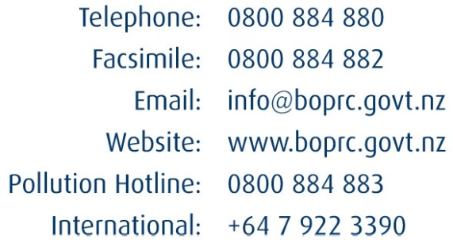
File ref:

 | SEEN |  | SEEN

Office Use Only

Application for a Resource Consent – Resource Management Act 1991 (s.88)
5A Water Consent Application (s.14) Take Surface Water

Before you make an application it is recommended that you talk or meet with a Consents Officer to discuss it. A Consents Officer may also be able to undertake a site visit to provide further advice.
If you would like to arrange this, please phone 0800 884 880.
If you are applying for more than one activity and you have already completed the basic details in Part 1 on another form, go straight to Part 2 of this form.
See notes to Applicant (last pages of form) before proceeding with application form.
Water take, diversion and/or damming activities are subject to rules in the Regional Water and Land Plan. In addition activities within the Tarawera River Catchment may be subject to the Tarawera River Catchment Plan.
These plans can be found on our website http://www.boprc.govt.nz/knowledge-centre/plans/.
Reviewing and understanding the rules and assessment criteria applicable to your activity will assist you with preparation of your assessment of environmental effects.
Which rules of the above plan(s) are applicable for your activity?

What is the activity status of your consent application?
Controlled
Restricted Discretionary
Discretionary
If you need assistance determining which rules and activity statuses are applicable for your activity please call 0800 884 880 and ask to speak to the Duty Consents Officer for guidance.

Under Section 88 of the Resource Management Act 1991, the undersigned makes this application for resource consent(s).
PART 1 SEE FORM 1A
- Full name of applicant(s) (the name that will be on the consent)
Surname:
First names:
OR
If the application is being made on behalf of a trust, the Trustees must be named.
Trust name:
Trustees’ name:
OR
Company name:
Contact person:
Postal address:
Telephone (please tick preferred contact number)
Residential ( ) Business ( )
Cell ( )
Facsimile
Email

- Details of consultant (or other person authorised to make application on behalf of applicant)
Company name:
Contact person:
Postal address:
Telephone (please tick preferred contact number)
Residential ( ) Business ( )
Cell ( )
Facsimile
Email
All correspondence, including invoices for charges, relating to this application(s) should be sent to:
Applicant Consultant

- Name and address of owner/occupier (of the site relating to application)
Owner:
Postal address:
Residential ( ) Business ( )
Occupier:
Postal address:
Residential ( ) Business ( )
Please note: If the applicant is not the owner of the land to which the activity relates, then it is good practice to submit the application with written approval from the landowner.

- Consent(s) being applied for from Bay of Plenty Regional Council
- You will need to fill in a separate form for each of the activities you propose to undertake. You may also need consent for one or more of the following.
Land Use
Form 1A Culverts, Bridges, Fords, Erosion Protection, Pipes and Associated Works
Form 1B Disturbance In or Around a Water Body (e.g. diversion, dredging, wetland disturbance, grave extraction)
Form 1C Lake Structures (new and existing)
Form 2A Land Disturbing Activities (e.g. earthworks and quarrying)
Form 2B Land Disturbing Activities (forest harvesting/vegetation clearance)
Discharge (including coastal)
Form 3A Onsite Effluent Discharge
Form 3B Discharge Farm Dairy Effluent
Form 3C Land Use Activities in the Catchments of Lake Ōkāreka, Rotoehu, Ōkaro, Rotorua and Rotoiti
Form 4A Discharge Stormwater to Water and/or Land from Urban Residential, Rural
Form 4B Industrial Discharges to Water or Land (including stormwater)
Form 4C Discharge Contaminants to Air

Water (including coastal)
Form 5A Water Permit Application (s.14) – Take Surface Water (includes intake structure (s.13))
Form 5B Water Permit Application (s.14) – Take Groundwater
Form 5C Dam Water
Form 5D Divert Water
Form 6A Geothermal Take and Discharge – Domestic and Light Commercial/Industrial
Coastal (see point 4 of Notes to Applicant for explanation of the Coastal Marine Area)
Form 7A Application for Consent for Coastal Structures (including associated occupation and disturbance)
Form 7B Application to Disturb Coastal Marine Area (no structure)
- In which district is the activity located?
Whakatāne District Ōpōtiki District
Rotorua District Kawerau District
Western Bay of Plenty District Tauranga District
Taupō District
- Is this application to replace an existing or expired consent(s)? Yes No
If Yes, please state the consent number(s)

- Please specify the duration sought for your consent(s).
years months
Start date
Completion date (if applicable)
- Do you also require resource consent(s) from a District Council? Yes No
Type of consent required
Has it been applied for? Yes No
Has it been granted? (If Yes, please attach) Yes No

- Location description of activity
Site address
Legal description (legal description can be obtained from your Certificate of Title, valuation notice, or rate demand)

Map reference NZTM, (if known)
Is your water take in a fully allocated catchment? Yes No
If you are unsure call the Consents Team on 0800 884 880.

PART 2
- Description of activity See Attached 'Lake Okareka Consent Application and AEE
- Purpose of water take (tick all that apply)
Industry/municipal
Frost protection
Irrigation
Temporary for bore drilling or dust control
Spraying
Dairy shed
x Other (please specify)
Modification of an existing discharge structure from the outfall of Lake Okareka to the Waitangi Stream to increas the maximum discharge from239L/s to 500L/s. note there is no 'water take' all of the piped water willbe discharged into the waitangi Stream.
Under s.14(3)(b) of the Resource Management Act, water can be taken without resource consent for:
- An individual’s reasonable domestic needs.
- The reasonable needs of an individual’s or animals’ for drinking water.
and:
the taking or use does not, or is not likely to have an adverse effect on the environment.
- Name or watercourse Lake Okareka and Waitangi Stream
- Type of watercourse
River or stream Modified river or stream
Lake or pond Main-made drain privately managed
x* Man-made drain managed by the Bay of Plenty Regional Council
Other (please specify)
* Until the 1960s there was no surface outlet from Lake Okareka. The current discharge is a constructed canal feeding into a gravity pipe system which discharges into the headwaters of the Waitangi Stream.

- Water intake structure (s.13(1)(a))
- Screen details
Mesh size (standard: < 5 mm x 30 mm mesh, or < 5 mm diameter holes or < 3 mm x 30 mm mesh in tidal areas)
Diameter of intake screen mm
Length of intake screen mm
Pumping velocity through screen (standard: < 0.3 m/s) mm
The canal feed into the existing pipe system is covered by resource consent 60776 which allows a discharge rate of up to 239L/s and Emergency Works consent which allows for a maximum discharge rate of 500L/s but increasing the flow in the existing pipe and adding a second pipe and pump.
Other than adding a second pipe there will be no change to this system. There is a debris grill in front of the pipe but this is to prevent woody debris entering and blocking the pipe. The structure conveys the total surface outflow from Lake Okareka. In order to convey this volume of water is not possible to install fine mesh screen over the intake strictures as recognised by the current resource consent.

There is no screen over the current pipe intake.
- On the following page, please provide detailed plans of the intake structure and its placement over/in the bed of the watercourse. Photos are also useful.

See Attached 'Lake Okareka Consent Application and AEE

Plan of intake structure and its placement over/in the bed of the watercourse.

- Water take
There will be no 'water take' in that the volume discharging form the lake will be fully discharged into the Waitangi Stream.
- Notes regarding water take applications:
- Efficiency of the volumes of water you are applying for will be tested by the Regional Council. This may include assessing volumes of water against the area of land the water is to be applied to, to check the application rate is efficient for your soil and crop. Council currently use SPASMO as a best practice tool to determine efficiency of use for irrigation only.
- Previous consented volumes (for replacement applications only) compared with actual use may also be taken into consideration. In both cases, volumes of water may be adjusted accordingly.
- Council considers some water bodies as being near or fully allocated. Please contact Council with regard to the water body you are seeking to take water from.
- If your rate of take is 5 litres per second or more, you must comply with the Resource Management (Measuring and Reporting of Water Takes) Regulations 2010 which came into effect 10 November 2010. These regulations can be viewed online at: www.newzealand.govt.nz or www.mfe.govt.nz (Info 544). These regulations include installation of an appropriate measuring device (e.g. water meter), monitoring and reporting requirements. These regulations will be given effect to by conditions of resource consent. If you have any questions about the regulations, please contact the Duty Consents Officer at the Regional Council.
- If your rate of take is less than 5 litres per second, the Regional Council requires installation of an appropriate measuring device (e.g. water meter), monitoring and reporting requirements as a condition of resource consent.
- Please carefully consider the volumes/rates of take of water you are applying for. It is likely larger volumes/rates of take will be subject to more stringent monitoring/reporting requirements and there will be greater ongoing charges associated with the consent.
- For industry/municipal
Rate of take L per second
Maximum time hours per day
Maximum volume m³ per day
- For irrigation
Rate of take L per second
Maximum time hours per day
Maximum volume m³ per day AND m³ per week
Area ha
Crop(s) *Please show area(s) of specific crops on an aerial map and advise land area of each.
Irrigation days per year:
- For frost protection
Rate of take L per second
Maximum time hours per day
Maximum volume m³ per day
Area ha
Crop(s) *Please show area(s) of specific crops on an aerial map and advise land area of each.
Frost days per year: The standard allocation equates to 15 days per year. If your application requires a greater number of days, please provide additional information to support this request.
Lowest temperature frost event designed for
- For temporary take
Rate of take L per second
Maximum time hours per day
Maximum volume m³ per day
Number of occurrences per year
- Other (please specify)

- Description of site
Attached 'Lake Okareka Consent Application and AEE
Describe the physical attributes of the site (e.g. ecology (fish, eels), streambed substrate, wildlife habitats (wetland, etc.). It would be useful to include photographs.

[Continue on a separate sheet if necessary]

- Assessment of Environmental Effects (AEE)
See Attached 'Lake Okareka Consent Application and AEE
Please attach a separate sheet/report detailing effects where appropriate. As a minimum, the following topics should be individually covered:
- The impact the activity is expected to have on the bed during construction.
- Long-term effects on the watercourse.
- Effects on fish passage.
- Other effect (e.g. groundwater reduction).

- Proposed mitigation methods.
- Other impacts such as recreational.
*Please note that consultation with relevant iwi groups may be required to accurately determine possible cultural effects of your proposal. Please contact Council’s Māori Policy Team to identify the relevant iwi/hapū groups.

- Efficiency of use
Please describe the water distribution system, including efficiency measures, control systems, and management regime. Include plans where relevant.

[Continue on a separate sheet if necessary]

- Cultural Effects
See Attached 'Lake Okareka Consent Application and AEE
Please provide an assessment of the cultural effects associated with the activities you propose.
The Regional Council’s Regional Policy Statement is clear that only tangata whenua can identify their relationship with an area. It is good practice to consult with tangata whenua in relation to your application so that you can provide the correct information to answer this question.
The Regional Council can provide a list of tangata whenua who have registered an interest in the site of your activity so that you can undertake the assessment. We can also provide other information e.g. access to iwi and hapū management plans, details about identified archaeological sites and details of any Statutory Acknowledgements relevant to the site. Please contact the Consents Team on 0800 884 880 to get more information.

- Persons likely to be affected
See Attached 'Lake Okareka Consent Application and AEE
Affected persons may include neighbouring land owners and occupiers, and/or organisations such as the Department of Conservation, Land Information New Zealand (LINZ), Eastern Region Fish and Game Council, relevant iwi and hapū and community groups.
If you do not think there will be affected persons, you do not need to fill out this section; however, the Bay of Plenty Regional Council will make the final assessment of whether a person is affected by your proposal, and it is recommended as best practice to consult with those persons.
In order for your application to be considered for non-notification you must gain written approval from all persons who may be affected by the proposal. The Bay of Plenty Regional Council can help you identify people/organisations that are likely to be affected, and the form ‘Affected Person’s Written Approval’, which can be filled out by the affected person and attached to this application, can be found at www.boprc.govt.nz keywords ‘resource consent forms’.

Please provide details below of those you have identified as persons who may be affected. If you have discussed your proposal with any of these persons, please record any comments made by them and your response to them, and submit this with your application.
Name
Address
Written approval supplied (attached).
Name
Address
Written approval supplied (attached).
Name
Address
Written approval supplied (attached).
Name
Address
Written approval supplied (attached).
[Continue on a separate sheet if necessary]

- Extending timeframes
The Resource Management Act 1991 (RMA) specifies timeframes for processing resource consent applications (e.g. 20 working days for a non-notified application); however these timeframes can be extended, if necessary, with the Applicant’s agreement.
Do you agree to the Bay of Plenty Regional Council extending RMA consent processing timeframes?
Yes, provided that I can continue to exercise my existing consent until processing of this application is completed (renewal application only).
Yes, provided that the extension is for the specific purpose of discussing and trying to agree on consent conditions.
Yes, provided that the application process is completed before
No.

- Deposit fee
A deposit fee of $774.00, inclusive of GST, is payable with this application. This may be paid online, by cheque, or by eftpos at one the Regional Council’s reception desks.
- Bay of Plenty Regional Council’s bank account number is 06 0489 0094734 00. Please use the Applicant’s name as the reference. A GST invoice marked “PAID” will be issued on receipt of payment.
- An application will not be accepted as a complete application until the deposit fee has been paid. Please note: while we are happy to hold the forms in the meantime, the processing time will not start until payment is received.
- Additional charges are usually incurred, and will vary depending on the resource we use in the course of processing your application (e.g. staff time). Staff can give an estimate of expected costs. Please see the schedule of fees attached.

Checklist
If you have dealt with a staff member regarding your consent application, please provide their name here:

The following information must be included in your application to ensure it is accepted.
Complete all details applicable in this application form.
Include an Assessment of Environmental Effects (AEE) of the activity, as set out in Schedule 4, summarised at the back of this form (also refer Section 5 of this form).
Supply written approval from all affected parties, if any, and/or summary of consultation carried out.
Include a site plan.
Details and diagram or photo of Water Intake Structure.
Sign and date the application form.
Pay the required deposit.
Include any other information you think relevant (e.g. Certificate of Title, details from the Companies Register, etc.)
If your application is a large application, please submit an electric version on CD, and one hard copy.
Assessment of cultural effects (refer Section 7 of this form).
Please be aware any unchecked boxes may result in your application being returned under s.88.

Information privacy issues
The information you provide in this application is regarded as official information. It is required under the provisions of the Resource Management Act 1991 to process this application, and to assist in the management of the region’s natural and physical resources.
The information will be held by Bay of Plenty Regional Council, Quay Street, Whakatāne. This information is subject to the provisions of the Local Government Official Information and Meetings Act 1987, and the Privacy Act 1993. The information you provide in this application will generally be available to the public. If there is any information that you would like to remain confidential please contact a Consents Officer to discuss.
Failure to provide this information will mean that Bay of Plenty Regional Council will be unable to process your application.

1 I confirm that I have authority to sign on behalf of the party/ies named as the applicants for this consent.
2 I have read, and understand, all of the information contained on this application form, including the requirement to pay additional costs that will be itemised.
3 I confirm that all the information provided is true and correct and understand that any inaccurate information provided could result in my resource consent later being cancelled.

Signature SEE Form 1A Date

IMPORTANT
NOTE TO THE APPLICANT
PLEASE READ THIS BEFORE PROCEEDING WITH THE APPLICATION FORM
If you are unsure whether you require a resource consent for your proposed activity, or you have any other queries, please contact a consents officer at Bay of Plenty Regional Council on 0800 884 880.
IMPORTANT INFORMATION
1 Processing of the application by Bay of Plenty Regional Council will not begin until the deposit fee of $774.00 (including GST) is paid, unless prior arrangement has been made. If, at the end of the processing of the application, the actual cost exceeds the deposit, you will be invoiced for the balance.
2 You may also be required to pay a resource management charge associated with holding a consent. The Water Administration Team will be able to provide you with more details. All charges are in accordance with Section 36 of the Resource Management Act 1991. All accounts are payable by the 20th of the month following date of invoice. Where costs are incurred that exceed $2,000 above the deposit, or at the end of every quarter, you may be requested to pay an additional amount by way of interim payment against the final total costs.
3 The Coastal Marine Area is the area from the outer limit of the territorial sea (12 nautical miles) to the line of mean high-water springs. For activities at river mouths, please contact a consents officer at Bay of Plenty Regional Council for clarification.
4 Section 42 of the Resource Management Act 1991 allows the protection of sensitive information. Therefore, if your application includes trade secrets and/or commercially and culturally sensitive material, please advise Bay of Plenty Regional Council.
5 Schedule 4 of the Resource Management Act 1991 (summarised at the back of this form) sets out the information you must provide with your consent application, including an Assessment of Environmental Effects (AEE). An AEE must be prepared in accordance with Schedule 4 of the Resource Management Act 1991. To assist in the preparation of the assessment, a summary of the key requirements of Schedule 4 follows this information sheet. Failure to provide the correct information will result in delays in the processing of your application.
6 Bay of Plenty Regional Council may decide not to proceed with the application until applications for further resource consents are made (Section 91). It is, therefore, important to identify every consent required for the proposal at the outset.
7 Bay of Plenty Regional Council may request the Applicant, by written notice, to provide further information if required (section 92). If this occurs, the application will be put on hold, and the processing timeframes stopped. Processing will not recommence until the information is received.
8 An application does not need to be publicly notified if the environmental effects are minor, and if written approval has been obtained from everyone who is adversely affected by the granting of the consent (Sections 95D and 95B respectively). Bay of Plenty Regional Council has forms available to obtain approvals.
9 Under Section 128(1)(c) of the Resource Management Act 1991, Bay of Plenty Regional Council may undertake a review of any consent at any time if the application contains any inaccuracies that materially influence the decision made.
How to prepare and Assessment of Effects on the Environment
As outlined in Schedule 4, Section 88(2)(b) of the Resource Management Act 1991

Summary of the key points of Schedule 4
You need to include enough information in your Assessment of Environmental Effects (AEE) so that the Regional Council can evaluate your proposal. The amount of information should correspond to the scale and significance of the environmental effects that may be generated by your proposal.
Your AEE needs to include:
- A full description of the proposal, including the site and locality (including a site plan and plans of your proposal).
- A description of the environmental effects, including the significance and nature of the effects (address specific environmental effects that you have identified, as well as referring to issues identified in the District and/or Regional Plan).
- A description of alternatives to avoid, remedy or mitigate any significant environmental effects.
- An assessment of any risks to the environment that may arise from hazardous substances, and/or the discharge of contaminants.
- A record of any consultation, including names and views of people with whom you talked.
- A discussion of any effects that may need to be controlled or monitored, how the control or monitoring will be carried out, and by whom.
You should also refer to Schedule 4 of the Resource Management Act 1991. This sets out matters that should be included and considered when preparing an AEE.
For more complex applications, you may need to get specialist advice. There are a number of professionals who assist in preparing AEEs, such as engineers and resource management consultants. Council staff may be able to tell you if you need specialist advice.
It is NOT adequate to state in your AEE that there are NO environmental effects.
It is important that you provide the Council with a well-prepared AEE; otherwise, the Council may:
- not accept your application,
- turn down your application,
- impose a lot of conditions on your resource consent,
- ask you for more information, delaying the time taken to process your application, or
- commission someone else to review your application at a cost to you.

For more detailed information
see the Ministry for the Environment’s Good Practice Guide on How to Prepare an AEE, and have a look at its brochure on making resource consent applications, at www.mfe.govt.nz/publications/rma
Bay of Plenty Regional Council
Section 36 Resource Management Act 1991
Charges Policy 2014-2015
Table 1: Consent application fees
General Application Fee (GST inclusive) Note: this is a deposit and other fees incurred will be recovered on an actual and reasonable basis.
- Resource Consent applications (except those specified below as fixed charges).  - Certificates of Compliance (excluding Onsite Effluent Treatment).  - Changes or cancellation of conditions of consents.  - Review of consent conditions.  - Transfer of consent to another site or another person at another site.  - Lapsing period extensions. | $774
- Publicly Notified Applications. | $10,000
Other application fees (GST inclusive)
Note: these are fixed charges with no additional costs payable.
Certificates of compliance – Onsite Effluent Treatment Regional Plan. | $50
Land use consent to construct a single geotechnical, freshwater bore or domestic geothermal bore. | $390
Applications for activities listed in regional plans that have zero fee. | $0
Transfer of consent to another person at the same site. | $90
Short term consent for five years or less for onsite effluent treatment systems in future reticulation zones. | $390
Application to reduce the allocated volume/rate in a water take consent. | $0
Applications for existing and previously consented structures on the Rotorua Lakes where the structure/s will remain unchanged, are not for commercial use and where the application follows a non-notified consent process. | $390
Notes
- Where fees are deposits only, the applicants will be charged all actual and reasonable costs above the deposit fee. Such costs may include, but not be limited to, staff time (see Schedule A), advertising, hearing costs (including costs of Committee members, Commissioners, Technical Appointees and the Minister of Conservation’s representative), disbursements, and costs of consultants.
- Where an application is withdrawn, the fixed fee of $500 will be retained and any actual and reasonable costs incurred will also be charged.
- Where costs are incurred that exceed $2,000 above the deposit, or at the end of every quarter, the applicant may be requested to pay an additional amount by way of an interim payment against the final total costs.
- In accordance with Section 36(7), the processing of any application may be suspended until any relevant charge is paid in full.
- Where the deposit fee exceeds the processing costs by $25 or more, the difference will be refunded to the applicant.
- Notwithstanding the above fee structure, the Consents Manager may require an appropriate application deposit fee for complex, multi-consent projects, or limited notified applications, up to a maximum of $10,000 (GST inclusive).
- Costs for Hearing Committee members and Commissioners will be recovered from applicants at their set charge- out rate. Disbursements will be charged at actual and reasonable cost.
- The deposit fee for a Review of Consent Conditions is payable by the 20th of the month following service of notice by Council.
- All charges apply from 1 July 2014.

Schedule A – Hourly fixed charges for staff and consultants (GST exclusive)
Grouping | Positions | Hourly Charge
Administration | Planning Administration Officer  Water Administration Officer  Pollution Prevention Administration Officer  Environmental Data Assistant  Committee Administration Officer | $77
Officers/Planners | Planner  Pollution Prevention Officer  Consents Officer  Maritime Officer | $95
Senior Officers/Senior Planners | Senior Consents Officer  Senior Pollution Prevention Officer  Senior Planner | $110
Engineer/Scientist/Project Officers | Environmental Engineer  Environmental Scientist  Project Implementation Officer | $114
Team Leader/Senior Project Officers/Works Engineer | Consents Team Leader  Pollution Prevention Team Leader  Laboratory Services Team Leader  Works Engineer  Senior Project Implementation Officer | $121
Senior Engineer/Senior Scientist/Harbourmaster | Harbourmaster  Senior Environmental Scientist  Principal Technical Engineer | $126
Managers/Regional Harbourmaster | Regional Harbourmaster  Consents Manager  Data Services Manager  Regional Integrated Planning Manager  Natural Resources Policy Manager  Science Manager  Pollution Prevention Manager  Engineering Manager | $162
Consultants | External Consent Processing or Specialist Technical Consultant | As charged by consultant

Note: Some positions may not be listed. In such cases the charge will be calculated from actual time (including travel time) charged at rates determined from annual salary plus on-cost.
The full Section 36 Charges Policy is available at
http://www.boprc.govt.nz/knowledge-centre/policies/section-36-charges-policy/

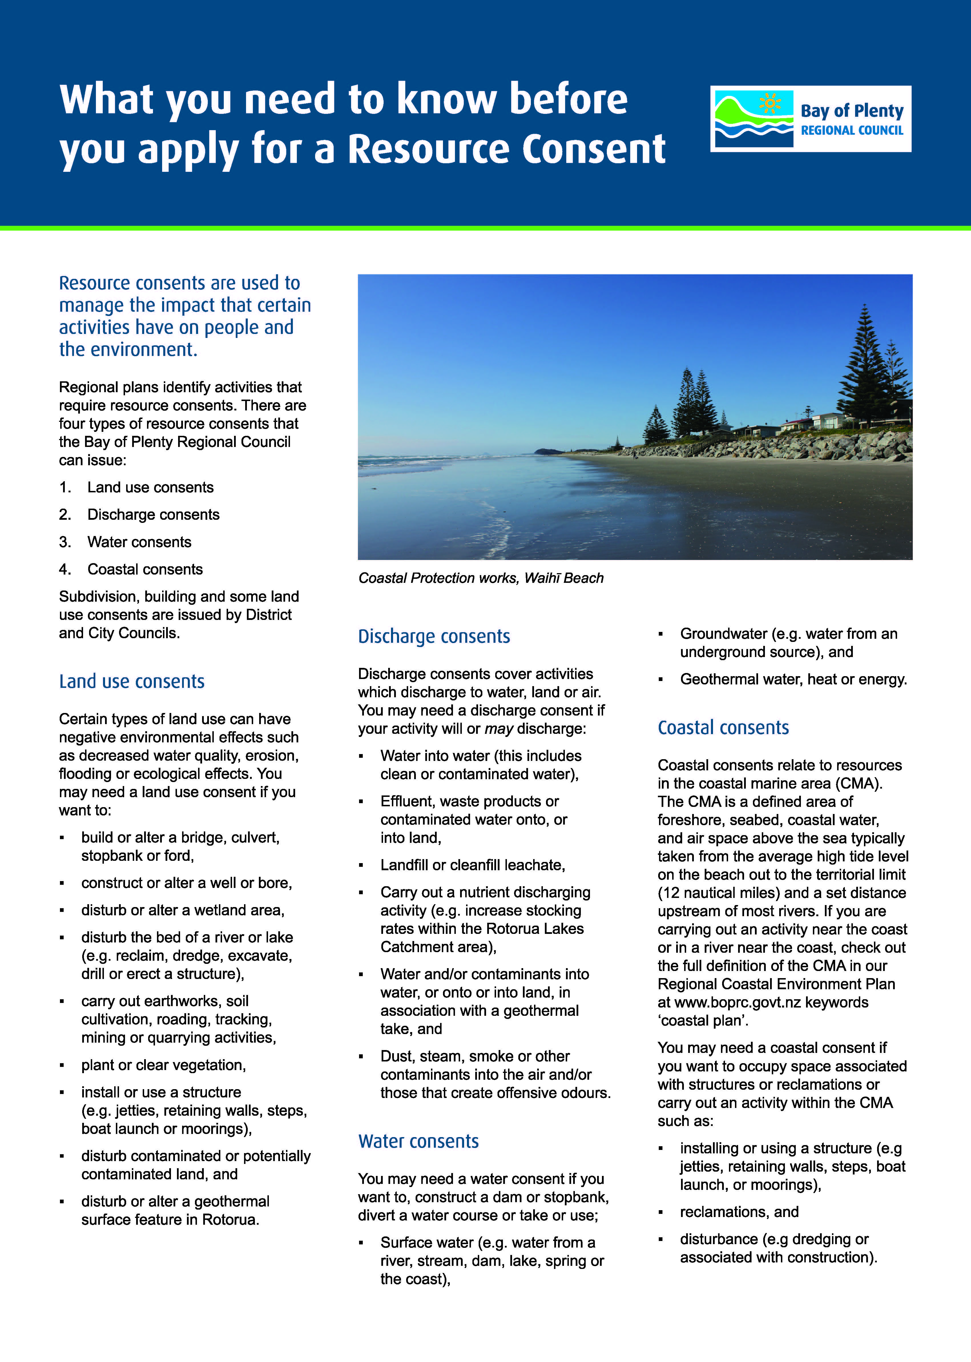

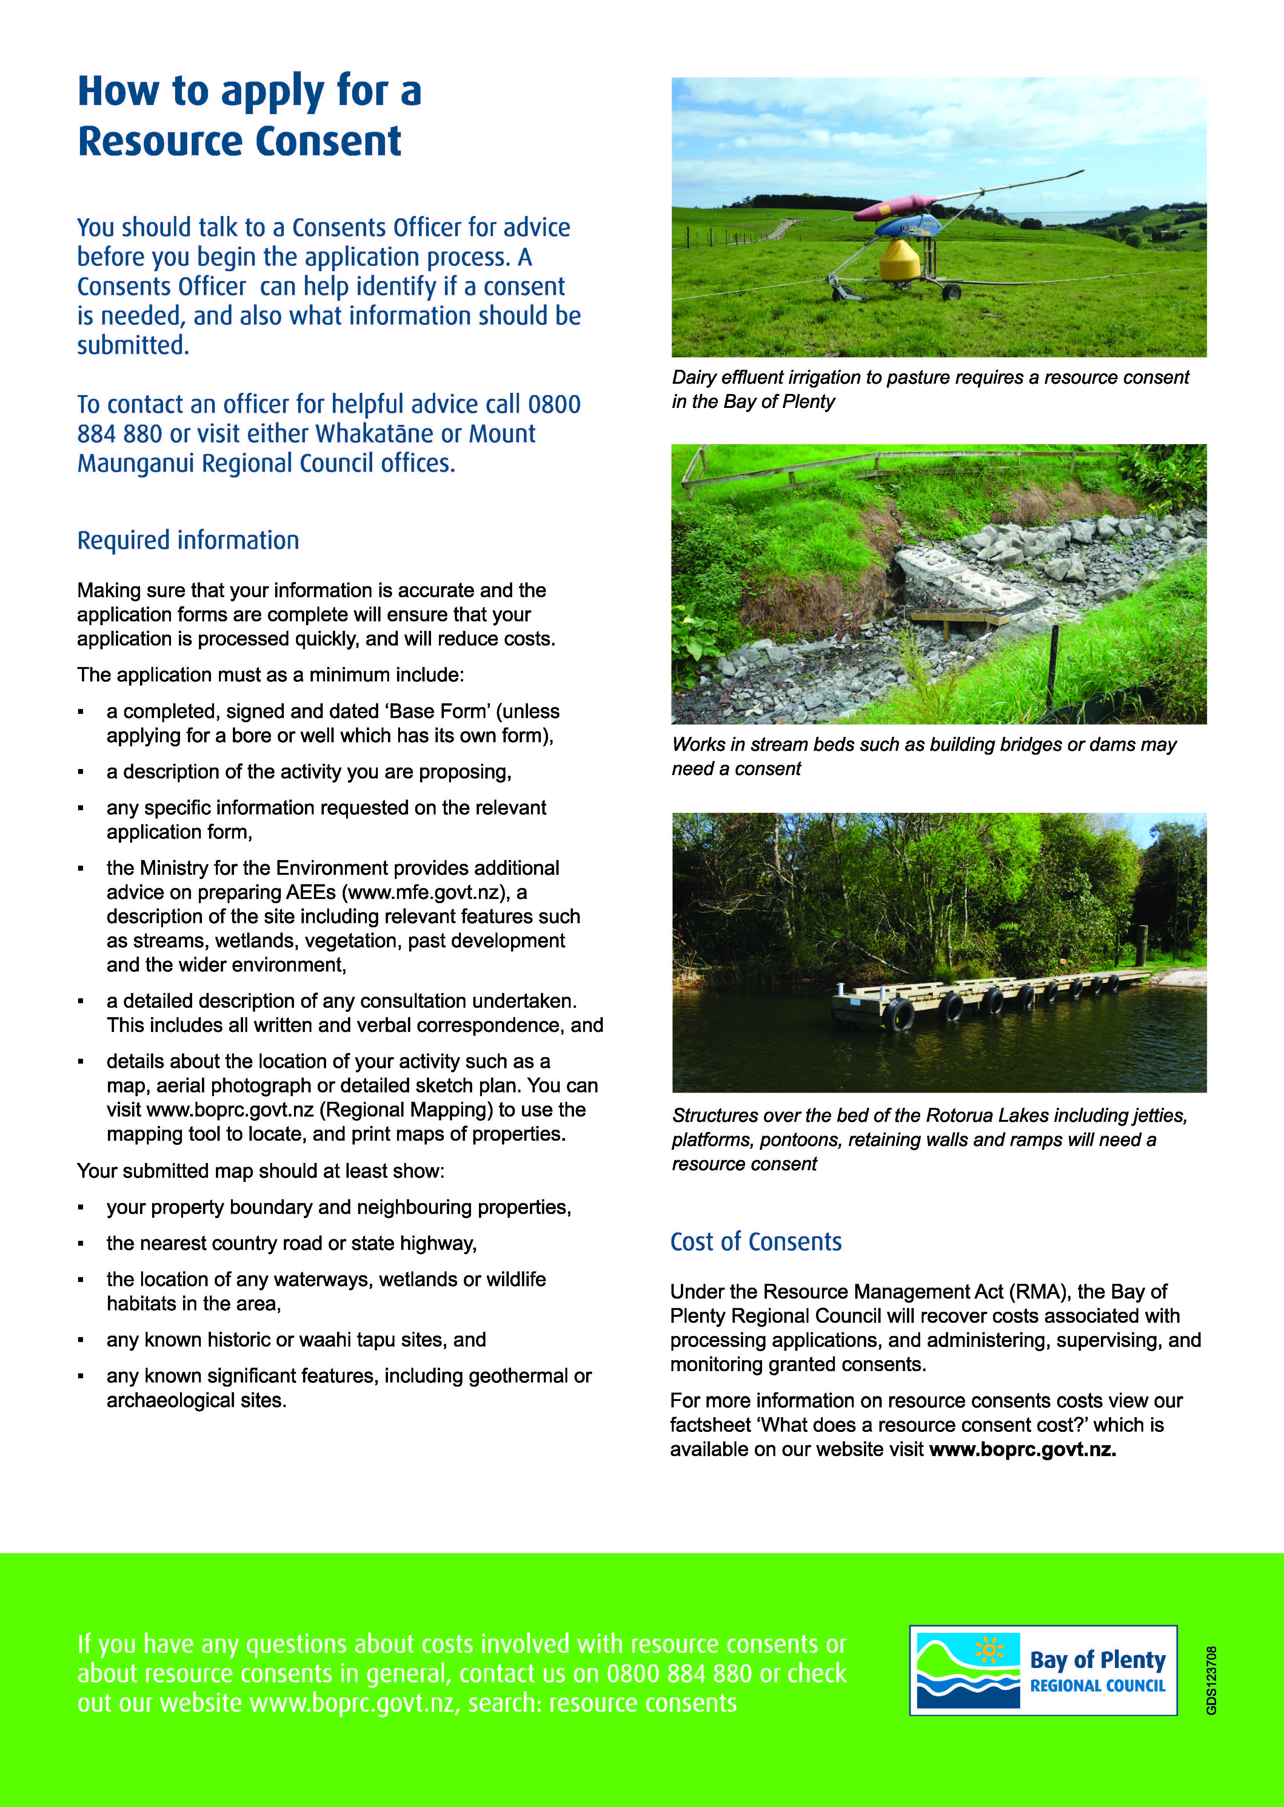

¹ At the time of writing, this includes some bore permits under the Rotorua Geothermal Regional Plan (Rule 19.6.3(d)), and some wetland works under the Regional Water and Land Plan (Rule 80 and Method 261).

