Lake Ōkāreka Pipeline

Engineering Comments for S92: Resource Consent Application CH17-00717

November 2017

Bay of Plenty Regional Council
5 Quay Street
PO Box 364
Whakatane 3158
NEW ZEALAND

Prepared by Niroy Sumeran (Lakes Operations Officer)

Background

Bay of Plenty Regional Council (Lakes Operations department referred as BOPRC going forward) operates an overland gravity pipeline which is used to control lake levels in Lake Ōkāreka. The pipeline was established in the 1960’s, operated by gate valve and discharges into the Waitangi Stream which flows into Lake Tarawera. The consented maximum discharge to Waitangi Stream is 239 L/s however the pipeline has a physical capacity to convey up to approximately 350 L/s. On Friday, 23rd June 2017 BOPRC invoked emergency works under section s330 of the Resource Management Act 1991 (RMA) in response to extremely high lake levels. Discharge to Waitangi Stream increased to approximately 350 L/s and was further increased to 500 L/s on the 8th of August 2017 using an overland pump and pipeline to convey an additional 150 L/s. A requirement under s330 is that a resource consent is lodged within 20 working days from the emergency invoked. This application was lodged on 21st July 2017.

Limited consultation with affected parties was undertaken prior to lodging the s330 consent application and because of this it was decided that the wider issue of long term lake level and discharge system management required further consultation. It was agreed with BOPRC (Consents department) consultants, Ryder Consulting that two resource consent applications will be made:

- The lodged emergency provision application to discharge up to 500 L/s until the lake level falls to within a manageable range; and
- a second application covering the long term management and use of lake control and discharge structures.

To this end, BOPRC have engaged a consultant to investigate long term lake management options. It is planned that once options are received, they will form part of the consultation discussion process for the second consent application. The investigation package will address robust engineering solutions to ensure the Waitangi Stream is capable of receiving flows of 500 L/s long term.
After reviewing the resource consent application lodged on 21st July 2017, the consent authority has requested further information under section 92 of the RMA. This includes a request for:
- A description of the risk of stream bed and stream bank erosion and likely sediment inputs from any increase in erosion. The assessment should include calculations of the anticipated sediment volume discharged as a result of the proposal.

- Detail of any erosion control structures that are proposed within or adjacent to the Waitangi Stream to mitigate the increased flow. Please also provide an assessment of these structures against the Bay of Plenty Regional Council’s Hydrological and Hydraulic Guidelines 2012 and the Erosion and Sediment Control Guidelines for Land Disturbing Activities 2010.

- Details and drawings of the energy dissipation structure and stream channel showing that they allow the passage of the maximum flow proposed of 500l/s flow without damage, including typical cross section(s) of the stream channel with the previous and proposed maximum flow level shown.

- Drawings and calculations to demonstrate the existing downstream structures will pass the 500l/s flow, without damage.
- A description of the frequency, duration and timing of high flow periods. Furthermore, detail of the ramping rates when flows are increased and decreased (associated with the temporary lowering of the lake level from its current level, as well as associated with its ongoing management).

In order to address the s92 request and provide support for the long term consent application, consultant engineers Sigma Consultants were engaged to undertake initial investigations and provide recommendations for mitigation. At the same time ecological and fisheries consultant Keith Hamill (River Lakes Ltd) was engaged to undertake an ecological survey to address the points raised in the s92 request.

The detail below provides information to address the engineering and hydraulic elements of the Section 92 questions relating to increasing discharge from 239 L/s to 500 L/s. Ecological aspects are addressed in Keith Hamill's report- 2017- Lake Ōkāreka overflow, Waitangi Stream: Ecology effects of increased flow. Resource consent application CH17-00717.

The Hamill report and this engineering assessment are BOPRC's response to the s92 request dated 9th August 2017.

Increasing Discharge

Stream gauging is recorded 5 m upstream of Culvert 1 (figure 1) and all discharge discussed below includes spring flow and any stormwater inflow into the Waitangi Stream at this point. Continuous telemetry has been installed and flows recorded since July 2017; any information can be made available on request. On the 23rd June 2017 discharge was increased to approximately 272 L/s and progressively increased to a maximum discharge of approximately 350 L/s on 6th July 2017. 500 L/s was achieved on the 8th of August 2017 by the addition of a second overland pipe and pump.

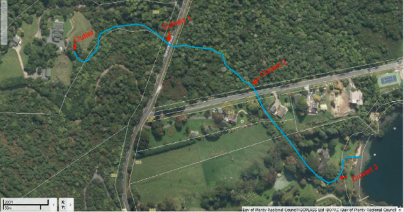

Figure 1: Waitangi Stream flow path.

BOPRC staff visually traversed the Waitangi Stream to baseline erosion from the discharge point to Lake Tarawera outfall prior to increasing flow (figure 1). Inspections between the 23rd June – 25th July 2017 found that Culvert 2 was hanging approximately 1.5 m (present prior to increased discharge) from the stream bed and the immediate section downstream of Culvert 2 had vegetation and debris creating partial stream blockage. The effect of this caused flows to be diverted towards the stream bank creating localised erosion. It was also found that Culvert 3 was partial blocked and running at approximately 90% capacity. An engineering consultant was engaged to provide:

- specification for bank protection between Culvert 2 (appendix 1);
- input for weir structures for energy dissipation;
- specification for energy dissipation for Culvert 2 and immediate downstream section (appendix 2);
- specification for adding an additional high-level 450 mm diameter pipe next to Culvert 3 (appendix 3); and
- input for erosion monitoring.

Outlet, Erosion Mitigation/monitoring and Culvert installation

The new overland pipeline outlet was installed 5-8 m downstream of the existing discharge point. The stream bed in this area had existing rock spawl placed for energy dissipation prior to the additional pipeline being installed. There was no evidence of erosion in this area prior to increasing discharge however additional rock spalls were placed at the new pipe outlet and along bank to further remove energy and protect stream bed in this area (see appendix 4).

After consultation and inspection by Sigma Consultants, the below mitigation and monitoring work was undertaken.

Culvert 2 had approximately 8 tonne of rock placed (200-400 mm in size) to bridge the hanging gap from the culvert apron to bed level. Energy dissipation also occurs in this area due to the irregularity of rock shapes. The outlet banks of Culvert 2 have a combination of Cirtex Secudrain (cloth and geotechnical grid material) pinned down with R10 hooked bodkins along with plywood to minimise scour from flow and splashing water as it exits the culvert and over the rocks (appendix 2). In addition, the rocks facilitate fish passage as it removes the hanging culvert as being a potential barrier to native fish passage.

Staff have continued to undertake visual erosion monitoring by traversing from discharge point to Tarawera outfall, initially done on a weekly basis however now undertaken monthly based on the erosion seen. Sections between the discharge outlet to Culvert 2 and downstream of the waterfall to Lake Tarawera outfall show no signs of significant erosion (refer to Hamill, 2017). Temporary bank/toe protection was installed at Culvert 2 to 40 m downstream and on both banks in accordance with engineering advice (see appendix 1). This area presents the biggest risk for bank and bed erosion as the bed fall from Culvert 2 is approximately 5-10% grade. In addition to this, there is a property located within 4 meters from the top of bank and undercutting could provide a risk of bank stability failure. Since the installation of toe protection, there is no evidence of undercutting in the immediate area of the property.

Ongoing Inspections are undertaken weekly between Culvert 2 to 40 m downstream to monitor bed erosion and in September, 6 cross-section transects were installed to map erosion profile (appendix 5). Unfortunately, there is no historical bed profile to draw quantitative bed erosion estimates however after an initial period of down cutting; T1-T5 shows signs of bed stabilisation with sediment deposition occurring in monitoring areas. Along the same section of stream are three, 600 mm v-notch weirs were installed to dissipate energy by increasing water depth and plunging water. A negative impact of the weirs is bed scour immediately downstream of the structures as the water plunges onto natural bed material. Rock has been placed in areas of vulnerability (see T6, appendix 5). Erosion and ecological impact is discussed further in Keith Hamill’s report dated 16 October 2017- Lake Ōkāreka overflow, Waitangi Stream: Ecology effects of increased flow. Resource consent application CH17-00717.

As discussed in the above section, it was identified that culvert 3 (800 mm dia.) had partial blockage and was not capable of handling a discharge of more than 350 L/s. At the risk of culvert failure a second high-level 450 mm diameter pipe was installed with the property owner’s permission to ensure if the existing culvert backed up the high-level pipe had the capacity to accommodate additional discharge. The high-level pipe was installed 200 mm from the crown of Culvert 3, is only operational at flows above 400 L/s and provides an approximate 160 L/s of additional capacity. Design for this is shown in appendix 3.

As far as reasonably practicable, during flow ramping/decreasing from June 2017 to current an effort has been made to adjust flow rates at approximately 150 L/s increments and at 30-60 minute intervals. BOPRC staff consulted with Eastern Regional Fish and Game as Trout spawning occurs in the lower sections of Waitangi Stream and staff maintained a minimum of 100 L/s during stream work activities. Ramping rates were only disregarded if there was an imminent Health and Safety risk or potential risk of asset damage.
Long Term Solution

Consultants have been engaged to provide long term lake level management options for Lake Ōkāreka. The work covers discharge options, toe and bed protection/mitigation for Waitangi Stream and water balance model’s for a variety of discharge and climatic scenarios. It is expected that the long term resource consent application will include detailed engineering and regulatory information to address hydrological, hydraulic, erosion and sediment requirements. This application will also include a reviewed lake level control strategy after consultation with community and affected parties.

Appendices

Appendix 1 Protection Downstream of Culvert 2
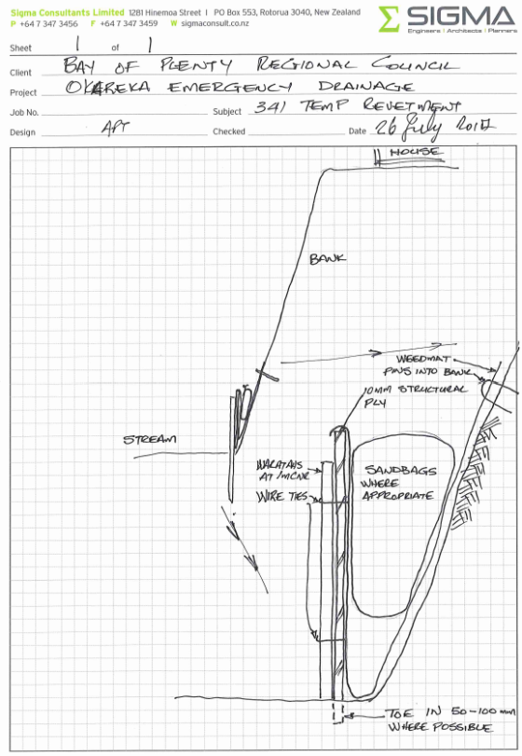
Engineering design for bank/toe protection.
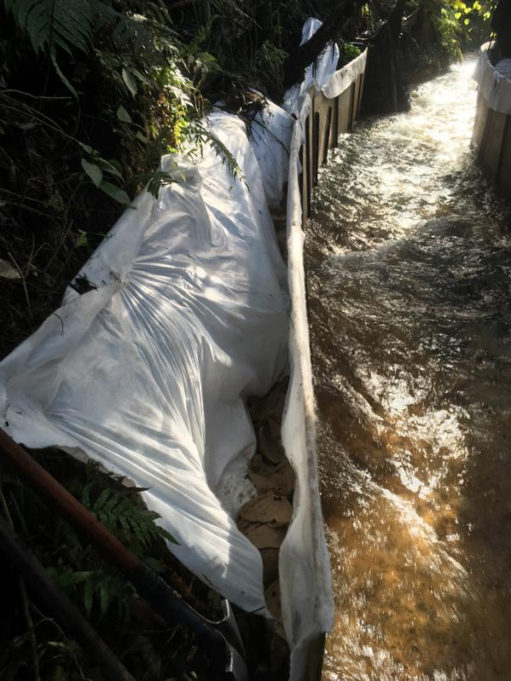

Plywood, geocloth and sand bag protection for stream banks.

Appendix 2 Protection below Culvert 2 Outlet

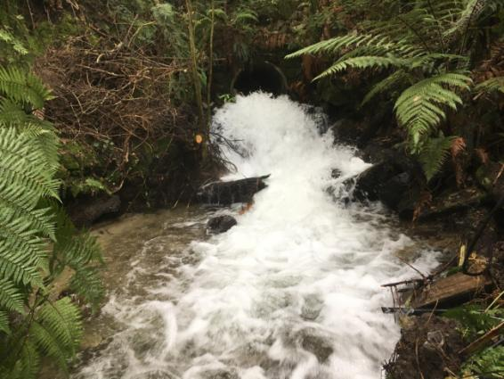

06/08/2017 Hanging Culvert 2 prior to rock and bank protection works.

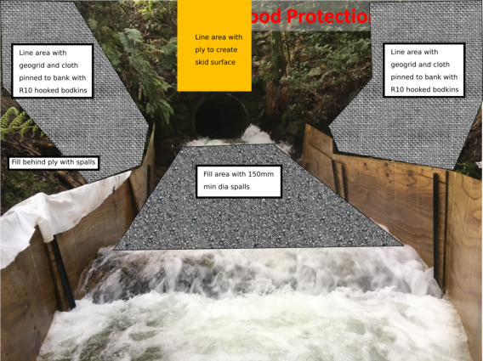
Engineering design for Culvert 2 outfall and bank protection.
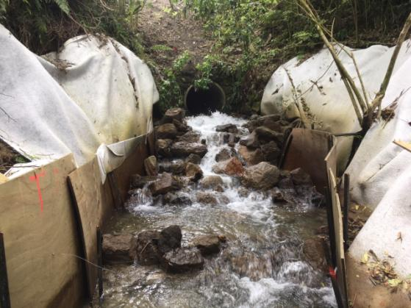

13/11/2017 Culvert 2 rock spawl at low flow approx. 100 L/s.

Appendix 3 Additional Culvert at Culvert 3 location

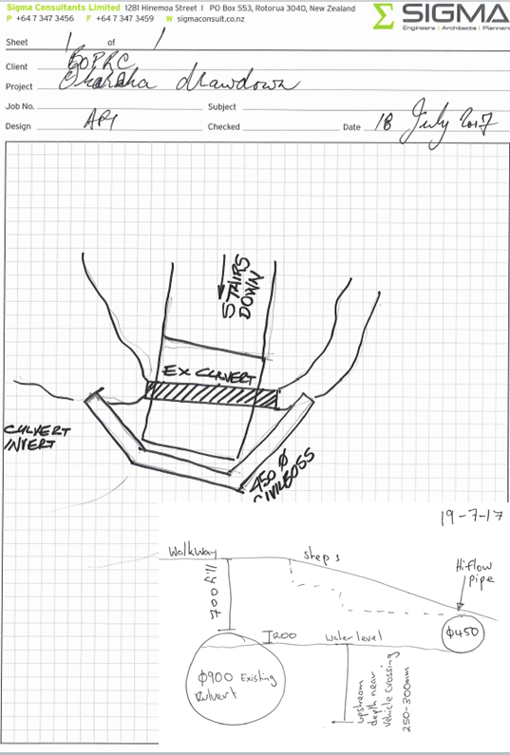
Engineering design for Culvert 3 high-level pipe.
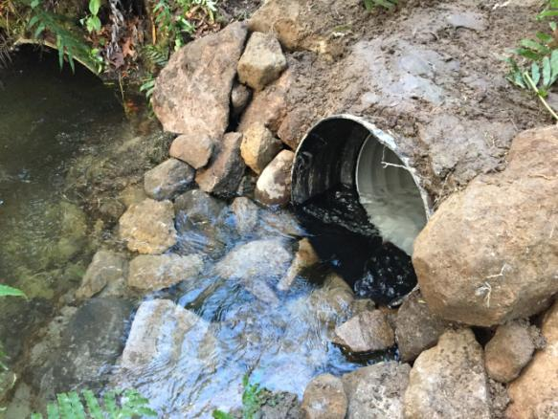
High-level pipe flowing at 500 L/s, existing Culvert 3 left hand side of photo.

Appendix 4 Existing and Additional Pipe Discharge and Energy Dissipation

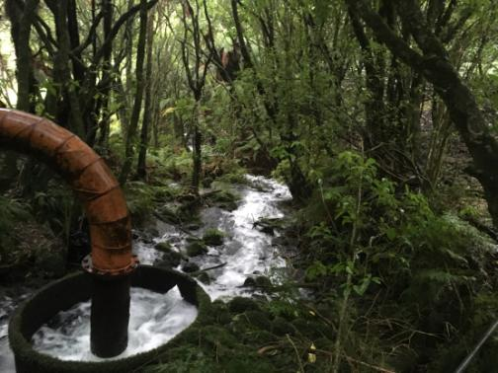

23-06-2017 Lake Ōkāreka outlet Structure prior to increased flow and additional rock work.

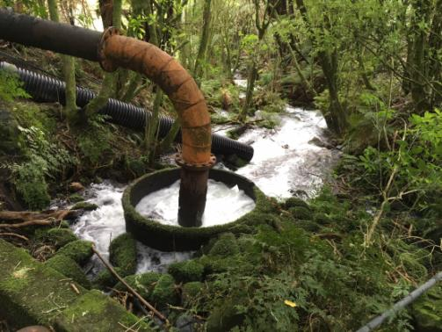

Overland pipeline in background approx.. 5-8 m downstream of existing pipeline
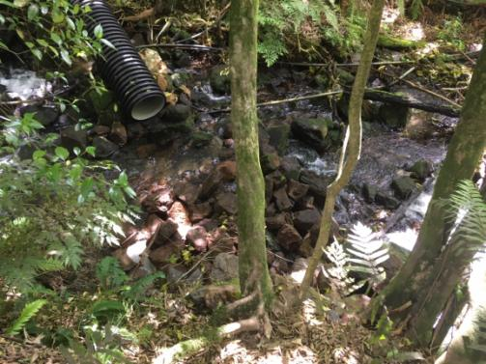

Additional rock spawl installed at overland pipeline outlet.

Appendix 5 Monitoring Cross-section and Bed Profile Graph

Cross-section transect (T) starting at T1 is closest to Culvert 2 and each of the 6 transects are spaced evenly over the 40 m monitoring section.

